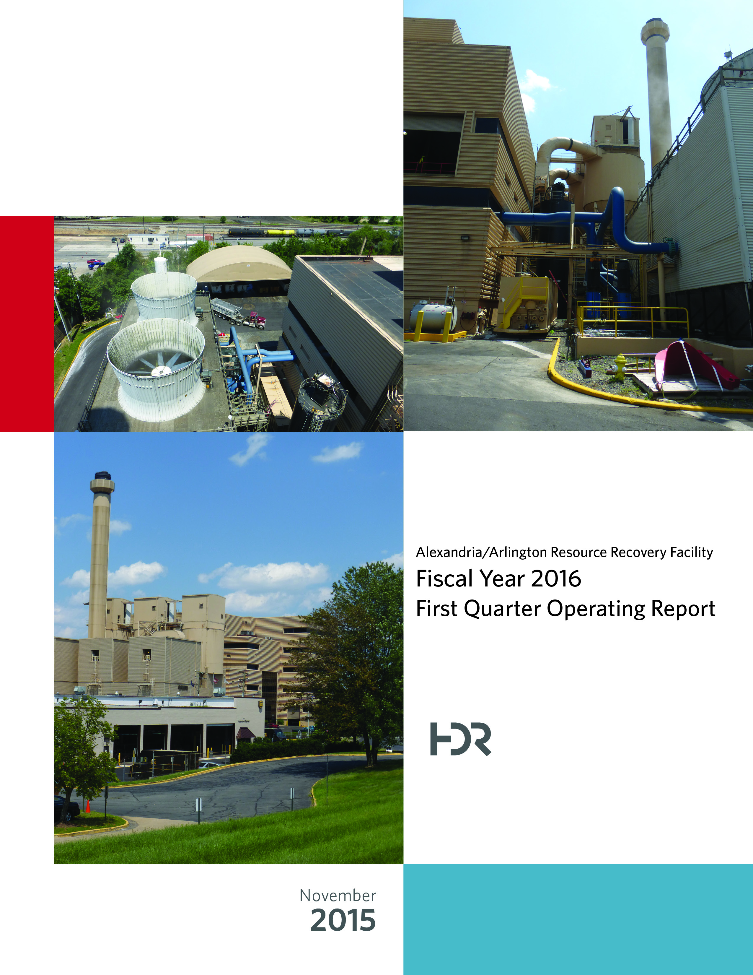

Table of Contents

Section No. Page No.

1.0 Purpose of Report 4

2.0 Executive Summary 4

3.0 Facility Inspection and Records Review 5

4.0 Facility Performance 9

4.1 Utility and Reagent Consumptions 23

4.2 Safety & Environmental Training 24

5.0 Facility Maintenance 25

5.1 Availability 26

5.2 Downtime Summary 26

5.3 Facility Housekeeping 30

6.0 Environmental 31

6.1 Nitrogen Oxide Emissions 31

6.2 Sulfur Dioxide Emissions 31

6.3 Carbon Monoxide Emissions 32

6.4 Opacity 32

6.5 Daily Emissions Data 32

6.6 Ash System Compliance 32

APPENDIX A FACILITY CEMS DATA 34

APPENDIX B PHOTOS 38

List of Tables

Table No. Page No.

Table 1: Summary of Audit Report Deficiencies 7

Table 2: Quarterly Performance Summaries 16

Table 3: Waste Delivery Classification 17

Table 4: Facility Utility and Reagent Consumptions 23

Table 5: Quarterly Facility Unit Availabilities 26

Table 6: Boiler Downtime – Q1FY16 28

Table 7: Turbine Generator Downtime – Q1FY16 29

Table 8: Facility Housekeeping Ratings – August 2015 30

Table 9: Unit #1 Monthly Summary for Reportable Emissions Data 35

Table 10: Unit #2 Monthly Summary for Reportable Emissions Data 36

Table 11: Unit #3 Monthly Summary for Reportable Emissions Data 37

List of Charts

Chart No. Page No.

Chart 1: Tons of Waste Processed 9

Chart 2: Tons of Ash Produced per Ton of Waste Processed 10

Chart 3: Ferrous Recovery Rate 11

Chart 4: Steam Production 11

Chart 5: 12-Month Rolling Steam Production 13

Chart 6: Steam Production Rate 14

Chart 7: Calculated Waste Heating Value 15

Chart 8: Cumulative Total Waste Delivery 18

Chart 9: Gross Electrical Generation 18

Chart 10: Gross Conversion Rate 19

Chart 11: Net Conversion Rate 20

Chart 12: Net Conversion Rate 21

Chart 13: Gross Turbine Generator Conversion Rate 21

Chart 14: Net Turbine Generator Conversion Rate 22

Chart 15: Quarterly Ash Test Results 33

List of Figures

Figure No. Page No.

Figure 1: Emergency light fixture, east side of Tipping Floor, not functioning in test mode – New Deficiency 39

Figure 2: Pot hole, southwest corner of Ash Trailer Canopy – New Deficiency 39

Figure 3: Firing Aisle – From south end looking north – No issues observed 39

Figure 4: Turbine Generators – No issues observed 39

Figure 5: Repaired charging floor parapet wall – deficiency closed 39

Figure 6: Refuse Pit – From north end looking south 39

Figure 7: SDA Penthouse – No issues observed (typical of all 3) 40

Figure 8: Cooling Tower Deck/Ash Trailer Canopy – Photo from SDA Penthouse 40

Figure 9: Boiler Steam Drum – General Observation 40

Figure 10: Supplemental Waste Elevator at south end of Charging Floor 40

Figure 11: Deaerator No. 1 Vessel – General Observation 40

Figure 12: Ash Trailer Canopy from Cooling Tower Deck – No issues observed 40

Figure 13: Main Condenser No. 2 – No issues observed 41

Figure 14: Metal Recovery Enclosure – General Observation 41

Figure 15: Ferrous Recovery Magnet 41

Figure 16: Economizers and SDAs – Photo from Cooling Tower Deck 41

Figure 17: Ammonia Storage Tank – General Observation 41

Figure 18: Facility Parking and Scales on north side of Facility – Photo looking east from Cooling Tower Deck 41

Figure 19: General Facility Photo from west side up Van Dorn 42

Figure 20: Steam Coil Air Heater – No issues observed 42

Figure 21: Tipping Floor Operations – No issues observed – Warning signs on all columns 42

Figure 22: Dominion Virginia Switchyard at Tipping Floor Entrance Road 42

Figure 23: Facility Battery Room – No Issues observed 42

Figure 24: Main Vibrating Ash Pan – No issues observed 42

**Definition of Abbreviations & Acronym**

|  |  |
| --- | --- |
| Abbreviation/Acronym | Definition |
| APC | Air Pollution Control |
| Apr | April |
| Aug | August |
| Avg | Average |
| Btu | British thermal unit |
| CAAI | Covanta Alexandria Arlington, Inc. |
| CEMS | Continuous Emissions Monitoring System |
| CO | Carbon Monoxide |
| Dec | December |
| ECOM | Emergency Communications |
| Feb | February |
| FMG | Facility Monitoring Group |
| FY | Fiscal Year |
| gal | Gallon |
| GAT | Guaranteed Annual Tonnage |
| HCl | Hydrochloric (Hydrogen Chlorides) |
| HDR | HDR Engineering Inc |
| ID | Induced Draft |
| Jan | January |
| Jul | July |
| Jun | June |
| klbs | Kilo-pounds (1,000 lbs) |
| kWhr | Kilowatt hours (1,000 watt-hours) |
| lbs | Pounds |
| LOA | Letter of Agreement |
| Mar | March |
| Max | Maximum |
| May | May |
| Min | Minimum |
| MSW | Municipal Solid Waste |
| MWhr | Megawatt hours |
| No | Number |
| NOV | Notice of Violation |
| Nov | November |
| NOx | Nitrogen Oxide |
| Oct | October |
| OSHA | Occupational Safety and Health Administration |
| PDS | Potomac Disposal Services |
| ppm | Parts per million |
| ppmdv | Parts per million dry volume |
| PSD | Prevention of Significant Deterioration |
| Q1 | First Quarter |
| Q2 | Second Quarter |
| Q3 | Third Quarter |
| Q4 | Fourth Quarter |
| RE | Reportable Exempt |
| RNE | Reportable Non-Exempt |
| SDA | Spray Dryer Absorber |
| Sep | September |
| SO2 | Sulfur Dioxide |
| TCLP | Toxicity Characteristic Leaching Procedure |
| VADEQ | Virginia Department of Environmental Quality |
| WL | Warning Letter |
| yr | Year |
| YTD | Year to date |

Alexandria/Arlington Waste-to-Energy Facility

First Quarter Operating Report – Fiscal Year 2016

# Purpose of Report

HDR Engineering, Inc. (HDR) was authorized by the Facility Monitoring Group (FMG) to conduct quarterly inspections and provide quarterly reports regarding the operation and maintenance of the Covanta Alexandria/Arlington Waste-to-Energy Facility (Facility) for the 2015 calendar year. This report is prepared for the first quarter of the 2016 fiscal year and summarizes Facility operations between July 1, 2015 and September 30, 2015. This report identifies the fiscal year beginning on July 1, 2015 as FY16 and the quarter beginning on July 1, 2015 as Q1FY16.

This report is based upon HDR’s experience in the waste-to-energy industry, upon site observation visits and previous reports provided by HDR, and upon data provided by Covanta Alexandria / Arlington, Inc. (CAAI), the Facility owner and operator.

# Executive Summary

CAAI operated the Facility in an acceptable manner and in accordance with established waste-to-energy industry practices during Q1FY16. The operation of the Facility, maintenance, safety, and overall cleanliness continue to be above average. Environmental performance was excellent with no reportable environmental excursions throughout the quarter.

During Q1FY16, the Facility experienced eight (8) instances of unscheduled downtime for the boilers totaling 98.8 hours, and four (4) instances of unscheduled downtime for the turbine generators totaling 75.0 hours. Beginning July 29, 2015, Boiler No. 1 experienced 35.5 hours of downtime for scheduled maintenance, and again, beginning September 19, 2015 for 100.0 hours. During the quarter, the boilers experienced three (3) instances of standby time totaling 106.8 hours, and Turbine Generator No. 1 experienced one (1) instance of standby time totaling 32.5 hours. Note that standby time isn’t factored into reported availability. A detailed listing of downtime is provided in Section 5.2 of this report.

Average waste processed during the quarter was 962.7 tons per day, or 98.7% of nominal facility capacity. Waste deliveries averaged 977.6 tons per day, which is 1.5% higher than the burn rate. The capacity utilization of 98.7% compares favorably to industry averages, which are generally in the 88% to 92% range.

Performance trends for various measurements are presented in Section 4. In general, the Facility continues to demonstrate reasonable consistency in month to month performance throughout the most recent three-year period tracked for detailed comparisons.

During the quarter, MSW processed increased 1.0% from the corresponding quarter in FY15; steam production increased 1.7%, and electricity generated (gross) increased 0.4% from the corresponding quarter in FY15. The increase in steam generation was attributable to the slight increase (0.3%) in the calculated average waste heating value, as well as less downtime (93.2 fewer hours) experienced by the boilers. The increase in gross electrical generation in Q1FY16 as compared to Q1FY15 is attributable to the increase in steam production, offset by more downtime (75.0 additional hours) experienced by the Turbine Generators.

# Facility Inspection and Records Review

In August 2016, HDR met with the Facility management and other plant personnel to discuss Facility operations and maintenance, acquire Facility data and reports, perform an independent visual inspection of the operating Facility, photograph areas of interest, and perform a review of recent Facility activity. This visit was coordinated with the scheduled FMG meeting. At the time of the inspection, HDR reviewed CAAI records, discussed performance issues with CAAI staff, and provided a verbal report and performance statistics at the FMG meeting. HDR maintains a running tabulation of the status of corrective actions and plant performance trends. CAAI provides the following documents for each month:

* Facility Monthly Operating Reports
* Monthly Continuous Emissions Monitoring System (CEMS) Reports

Table 1 summarizes maintenance, repair, and plant condition issues reported during this and prior audit reporting periods. An “A” indicates an issue of the highest priority and worthy of immediate attention. Such items are usually safety or operability issues. A “B” indicates that the issue needs to be dealt with as quickly as possible, but is not urgent. These items will usually result in a process improvement or will help avoid future “urgent” issues. A “C” indicates that the issue should be dealt with at the earliest convenience, but is not a priority issue. This category might include issues related to aesthetics, non-urgent maintenance, or housekeeping improvements which are not safety related.

Table 1: Summary of Audit Report Deficiencies

*A is highest priority & demands immediate attention: B needs attention, but is not urgent; C can be addressed at earliest opportunity & is not urgent.

| Item No. | Audit Report Deficiencies | Issue Reported | Priority* | HDR Recommendation | Status | Open / Closed |
| --- | --- | --- | --- | --- | --- | --- |
| 1 | Concrete to roadway drain at truck entrance damaged – exposing reinforcing bar | May 2014 | C | Repair damaged concrete | **Status Unchanged** | Open |
| 2 | Corrosion on ceiling panels in Turbine Generator Enclosure | August 2014 | C | Sand, Prime, Paint and Preserve, and replace deteriorated panels as necessary | **HDR observed the corroded/deteriorated sections had been primed, but no panels were replaced. CAAI reports that it plans to replace panels in 1 to 2 years.** | Open |
| 3 | Corrosion on ceiling panels in Turbine Generator Enclosure (Alternate Location) | August 2014 | C | Sand, Prime, Paint and Preserve, and replace deteriorated panels as necessary | **HDR observed the corroded/deteriorated sections had been primed, but no panels were replaced. CAAI reports that it plans to replace panels in 1 to 2 years.** | Open |
| 4 | Damaged Tipping Floor wall panels – Rainwater observed running from outside to inside | August 2014 | C | Repair damaged Tipping Floor wall panels | **Complete** | Closed |
| 5 | Deteriorated purlin east wall in Tipping Floor Enclosure | November 2014 | C | Replace deteriorated purlin | **Status Unchanged** | Open |
| 6 | Damaged curbing northeast corner of Facility near Citizen’s Drop-off | November 2014 | C | Repair curbing | **Status Unchanged** | Open |
| 7 | Damaged curbing west side of Cooling Towers | November 2014 | C | Repair curbing | **Status Unchanged** | Open |
| 8 | Damaged curbing near Ash Trailer Parking Area | November 2014 | C | Repair curbing | **Status Unchanged** | Open |
| 9 | Kick plates deteriorating on stairway east of Steam Coil Air Heaters | February 2015 | C | Replace stairway kick plates | **Complete** | Closed |
| 10 | Parapet on north end of Charging Floor damaged with exposed rebar | February 2015 | C | Repair concrete parapet | **Complete** | Closed |
| 11 | Panels on east wall in Charging Floor damaged | February 2015 | C | Replace damaged wall panels | **Status Unchanged** | Open |
| 12 | Missing Danger/Warning Sign (English Version) on Pit Column | February 2015 | C | Install proper danger/warning sign | **Complete** | Closed |
| 13 | Rotary Sootblower Gears Exposed (typical of all 3 boilers) at Crane Pulpit Elevation | May 2015 | A | Install protective cages around all sides of exposed gears. | **Status Unchanged** | Open |
| 14 | Induced Draft Fan No. 1 Lagging deteriorated, west side of CEMS Enclosure | May 2015 | C | Replace deteriorated Induced Draft Fan Lagging | **Status Unchanged** | Open |
| 15 | Emergency light fixture, east side of Tipping Floor, not functioning in test mode – See Figure 1 (Appendix B) | August 2015 | A | Repair emergency light | **Status Unchanged** | Open |
| 16 | Pot hole, southwest corner of Ash Trailer Canopy – See Figure 2 (Appendix B) | August 2015 | C | Repair road surface | **Status Unchanged** | Open |

# Facility Performance

Monthly operating data provided by CAAI indicates that 88,572 tons of MSW were processed during Q1FY16, and a total of 89,943 tons of MSW including 1,874 tons of Special Handling Waste were received. Total ash production during the quarter was 18,162 tons, which represents 20.5% of the waste processed. The average uncorrected steam production rate for Q1FY16 was 3.0 tonssteam/tonwaste, which is 0.7% more than the corresponding quarter in FY15. The increase in this metric is attributable to the increase (0.3%) in calculated average waste heating value that was experienced in Q1FY16, as compared to Q1FY15.

Chart 1: Tons of Waste Processed

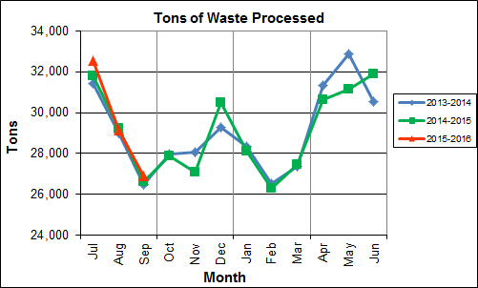

Chart 1 illustrates that Q1FY16 waste processed was higher (1.0%) than the corresponding quarter, Q1FY15.

CAAI reported that 450 tipping floor/MSW internal inspections were conducted during the quarter and no notices of violation (NOVs) were issued to the haulers.

Chart 2: Tons of Ash Produced per Ton of Waste Processed

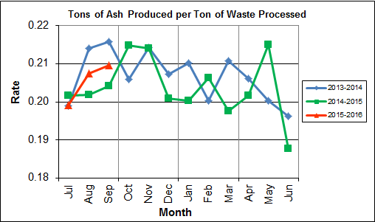

Chart 2 illustrates that the ash production rate in Q1FY16 were slightly higher (0.2%) at 20.5% of processed waste, compared to the corresponding quarter in FY15 when the rate was 20.3%. Ash production remains in the 20.0% to 21.0% range, as a result of the installation of the “semi-dry” ash discharger spray system in May 2012, and represents less moisture in the ash residue shipped to disposal.

Chart 3: Ferrous Recovery Rate

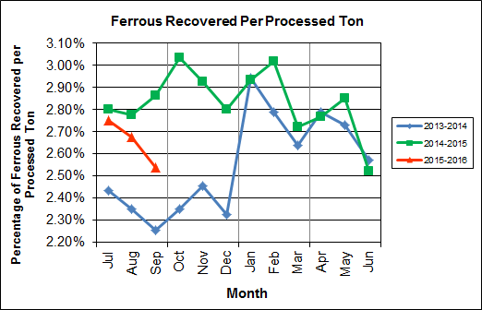

Chart 3 depicts the monthly ferrous metal recovery rate as a percentage of processed MSW tonnage. In Q1FY16, 2,357 tons of ferrous metals were recovered, which is 4.4% lower than the corresponding quarter in FY15 and equivalent to 2.7% of processed waste. CAAI reports that in recent months it noted that the ferrous recovery rate had decreased and it replaced an end section of the vibrating pan which was worn due to wear from material getting caught between the pan and magnet.

**Chart 4: Steam Production**

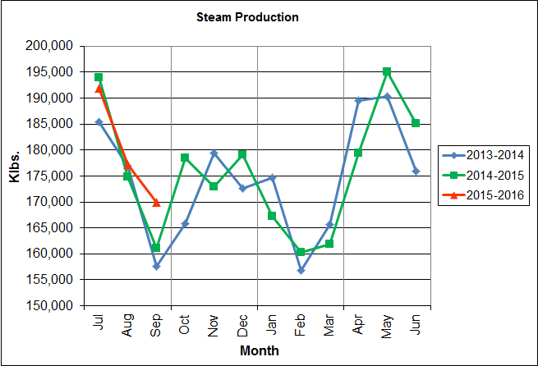

In Chart 4, the total steam production for Q1FY16 was 539,103 klbs., and 1.7% higher than the corresponding quarter in FY15. The increase in steam production is attributable to the increase (0.3%) in the calculated average waste heating value, as well as less downtime (93.2 fewer hours) experienced by the boilers.

Chart 5: 12-Month Rolling Steam Production

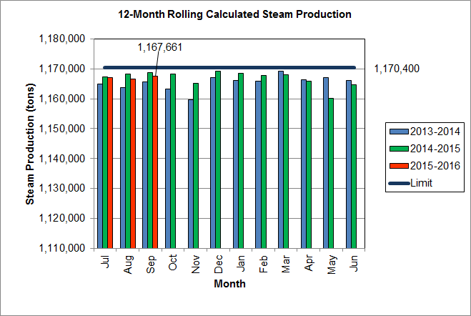

Chart 5 depicts the 12-month rolling steam production total for the period ending in September 2015. According to the Title V permit, the annual steam production for the Facility shall not exceed 1,170,400 tons on the basis of an average value of 3.34 lbs of steam per lb of MSW processed, calculated monthly as the sum of each consecutive 12 month period. The Facility was in compliance with the 12-month rolling steam production total every month in the quarter. The 12-month rolling total for steam production ending in September 2015 was 1,167,661 tons which is 99.8% of the limit. Chart 5 clearly shows that Facility throughput, and in turn, steam and electricity production are being throttled to stay ever so slightly below the steam production limit nearly every month.

Chart 6: Steam Production Rate

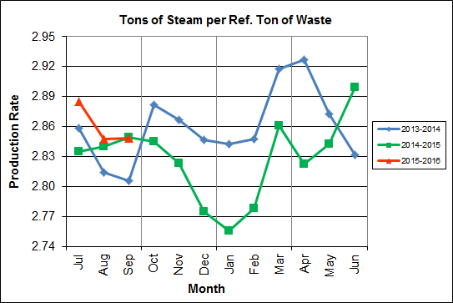

In Chart 6, the conversion of raw waste tonnages into “reference tons” is another way of analyzing steam production, and helps to determine whether changes are related to boiler performance or to fuel issues. “Reference tons” are adjusted to account for the calculated average fuel heating value, so that lower Btu fuel raw tonnages are adjusted upwards and vice versa. In Q1FY16, this metric tracked higher (0.7%) at 2.9 tonssteam/tonref, compared to the corresponding quarter in FY15.

Chart 7: Calculated Waste Heating Value

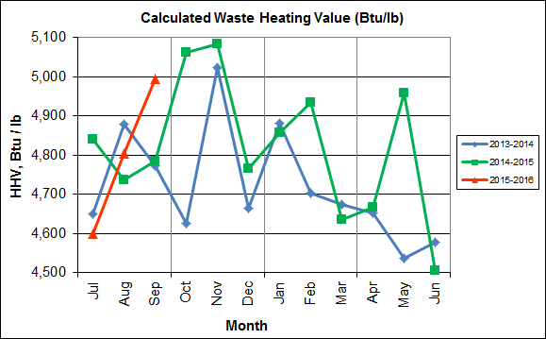

Chart 7 illustrates that Q1FY16 calculated average waste heating value was higher (0.3%) at 4,800 Btu/lb than the corresponding quarter Q1FY15, which averaged 4,787 Btu/lb.

Table 2: Quarterly Performance Summaries

|  |  |  |  |  |  |  |  |  |
| --- | --- | --- | --- | --- | --- | --- | --- | --- |
| Month | | Waste Processed (tons) | Waste Diverted  (tons) | Ash Shipped  (tons) | Special Handling (Supplemental)  (tons) | Ferrous Recovered  (tons) | Steam Produced (klbs) | Net Electrical Generation  (MWhr) |
| **Q1FY14** | **Quarterly Totals** | **86,884** | **0** | **18,167** | **1,470** | **2,043** | **519,971** | **35,635** |
| July -13 | 31,409 | 0 | 6,249 | 546 | 764 | 185,488 | 12,755 |
| August -13 | 29,000 | 0 | 6,206 | 676 | 682 | 176,948 | 12,208 |
| September -13 | 26,475 | 0 | 5,712 | 248 | 597 | 157,535 | 10,672 |
| **Q1FY15** | **Quarterly Totals** | **87,659** | **0** | **17,751** | **745** | **2,465** | **530,025** | **36,806** |
| July -14 | 31,818 | 0 | 6,417 | 141 | 891 | 193,977 | 13,779 |
| August -14 | 29,247 | 0 | 5,904 | 275 | 812 | 174,887 | 12,018 |
| September -14 | 26,594 | 0 | 5,430 | 329 | 762 | 161,161 | 11,009 |
| **Q1FY16** | **Quarterly Totals** | **88,572** | **0** | **18,162** | **1,874** | **2,357** | **539,103** | **37,062** |
| July -15 | 32,537 | 0 | 6,482 | 676 | 895 | 191,850 | 13,358 |
| August -15 | 29,150 | 0 | 6,047 | 427 | 780 | 177,256 | 12,048 |
| September -15 | 26,885 | 0 | 5,633 | 771 | 682 | 169,997 | 11,656 |
| **FY16 YTD Totals** | | **88,572** | **0** | **18,162** | **1,874** | **2,357** | **539,103** | **37,062** |
| **FY15 Totals** | | **348,686** | **0** | **71,019** | **5,413** | **9,864** | **2,109,442** | **145,085** |
| **FY14 Totals** | | **349,118** | **0** | **72,071** | **3,549** | **8,922** | **2,091,123** | **143,064** |

Table 2 presents the production data provided to HDR by CAAI for Q1FY16 on both a monthly and quarterly basis. For purposes of comparison, data for Q1FY14 and Q1FY15 are also shown, as well as FY14, FY15 and FY16 YTD totals.

In comparing quarterly totals, the data shows:

* More waste was processed in Q1FY16 than Q1FY15 and Q1FY14
* More steam was generated in Q1FY16 than Q1FY15 and Q1FY14
* More electricity was generated in Q1FY16 than Q1FY15 and Q1FY14
* Significantly more supplemental waste was received in Q1FY16 than Q1FY15 and Q1FY14.

Please note that the total steam generation figures presented in Table 2 do not correlate with the annual steam production limit from the Facility Permit; such limits apply on a 12-month rolling average monthly basis, and not a fiscal year basis. It is also worth noting that the quantity of waste processed during Q1FY16 and FY16 continues to be limited by the steam production permit restrictions (refer to Chart 5).

Table 3: Waste Delivery Classification

|  |  |  |  |  |  |  |  |  |  |  |  |  |  |  |  |
| --- | --- | --- | --- | --- | --- | --- | --- | --- | --- | --- | --- | --- | --- | --- | --- |
|  |  | **Jul** | **Aug** | **Sep** | **Oct** | **Nov** | **Dec** | **Jan** | **Feb** | **Mar** | **Apr** | **May** | **Jun** | **Totals** | **% of Total** |
| **FY12** | **Jurisdiction Waste** | 18,112 | 20,021 | 19,304 | 17,796 | 17,523 | 17,211 | 16,202 | 14,952 | 17,430 | 18,338 | 20,138 | 18,361 | 215,381 | 61.89% |
| **Spot Waste tons** | 8,901 | 13,623 | 13,303 | 9,788 | 11,976 | 11,900 | 10,276 | 10,697 | 10,283 | 10,029 | 11,333 | 10,177 | 132,295 | 38.01% |
| **Supplemental Waste** | 10 | 10 | 34 | 15 | 15 | 21 | 12 | 22 | 15 | 23 | 68 | 91 | 336 | 0.10% |
| **MSW Totals** | **27,023** | **33,654** | **32,641** | **27,599** | **29,514** | **29,132** | **26,490** | **25,672** | **27,729** | **28,390** | **31,539** | **28,629** | **348,012** | **100.00%** |
|  |  |  |  |  |  |  |  |  |  |  |  |  |  |  |  |
| **FY13** | **Jurisdiction Waste** | 19,413 | 18,357 | 16,632 | 17,625( | 18,838 | 16,195 | **-** | **-** | **-** | **-** | **-** | **-** | 107,058 | 30.76% |
| **Spot Waste tons** | 10,516 | 11,326 | 10,610 | 10,317 | 9,330 | 9,558 | **-** | **-** | **-** | **-** | **-** | **-** | 61,656 | 17.72% |
| **City Waste** | **-** | **-** | **-** | **-** | **-** | **-** | 1,683(1) | 1,287 | 1,444 | 2,382 | 2,286 | 1,919 | 11,000 | 3.16% |
| **County Waste** | **-** | **-** | **-** | **-** | **-** | **-** | 2,442(1) | 2,100 | 2,372 | 3,381 | 3,932 | 3,309 | 17,536 | 5.04% |
| **Municipal Solid Waste** | **-** | **-** | **-** | **-** | **-** | **-** | 25,019(1) | 23,637 | 21,661 | 27,066 | 25,794 | 24,930 | 148,107 | 42.56% |
| **Supplemental Waste** | 151 | 11 | 80 | 25 | 234 | 405 | 363 | 365 | 76 | 403 | 281 | 271 | 2,665 | 0.77% |
| **MSW Totals** | **29,928** | **29,683** | **27,241** | **27,942** | **28,167** | **25,753** | **29,507** | **27,388** | **25,552** | **33,231** | **32,293** | **30,429** | **348,022** | **100.00%** |
|  |  |  |  |  |  |  |  |  |  |  |  |  |  |  |  |
| **FY14** | **City Waste** | 2,065 | 1,693 | 1,702 | 1,924 | 1,566 | 1,780 | 1,529 | 1,231 | 1,556 | 2,256 | 2,203 | 1,883 | 21,389 | 6.11% |
| **County Waste** | 3,459 | 3,079 | 2,784 | 3,091 | 2,707 | 2,802 | 2,568 | 1,957 | 2,272 | 3,326 | 3,987 | 3,387 | 35,419 | 10.12% |
| **Municipal Solid Waste** | 26,167 | 23,604 | 22,034 | 23,354 | 21,879 | 25,531 | 23,869 | 22,523 | 23,198 | 25,414 | 27,206 | 24,812 | 289,590 | 82.75% |
| **Supplemental Waste** | 546 | 676 | 248 | 410 | 188 | 268 | 275 | 192 | 231 | 253 | 151 | 110 | 3,548 | 1.01% |
| **MSW Totals** | **32,237** | **29,053** | **26,768** | **28,779** | **26,340** | **30,380** | **28,241** | **25,903** | **27,256** | **31,249** | **33,546** | **30,193** | **349,946** | **100.00%** |
|  |  |  |  |  |  |  |  |  |  |  |  |  |  |  |  |
| **FY15** | **City Waste** | 1,814 | 1,497 | 1,699 | 1,737 | 1,518 | 1,770 | 1,411 | 1,209 | 1,648 | 2,155 | 2,059 | 2,045 | 20,562 | 5.91% |
| **County Waste** | 3,297 | 2,868 | 2,973 | 3,095 | 2,508 | 2,852 | 2,358 | 1,833 | 2,411 | 3,269 | 3,652 | 3,572 | 34,687 | 9.96% |
| **Municipal Solid Waste** | 26,661 | 24,466 | 21,887 | 21,241 | 21,678 | 27,906 | 24,611 | 20,915 | 24,094 | 25,189 | 23,126 | 25,667 | 287,442 | 82.57% |
| **Supplemental Waste** | 141 | 275 | 329 | 521 | 764 | 529 | 389 | 351 | 272 | 613 | 531 | 698 | 5,413 | 1.55% |
| **MSW Totals** | **31,913** | **29,106** | **26,888** | **26,595** | **26,468** | **33,057** | **28,769** | **24,308** | **28,424** | **31,225** | **29,369** | **31,982** | **348,105** | **100.00%** |
|  |  |  |  |  |  |  |  |  |  |  |  |  |  |  |  |
| **FY16** | **City Waste** | 1,960 | 1,563 | 1,723 |  |  |  |  |  |  |  |  |  | 5,247 | 5.83% |
| **County Waste** | 3,627 | 2,880 | 2,832 |  |  |  |  |  |  |  |  |  | 9,339 | 10.38% |
| **Municipal Solid Waste** | 27,933 | 22,999 | 22,552 |  |  |  |  |  |  |  |  |  | 73,483 | 81.70% |
| **Supplemental Waste** | 676 | 427 | 771 |  |  |  |  |  |  |  |  |  | 1,874 | 2.08% |
| **MSW Totals** | **34,196** | **27,869** | **27,878** |  |  |  |  |  |  |  |  |  | **89,943** | **100.00%** |
| **Note (1): Beginning January 2013, the method in which waste was classified was modified as compared to prior periods due to change in contractual obligations and plant ownership** | | | | | | | | | | | | | | | |

Chart 8: Cumulative Total Waste Delivery

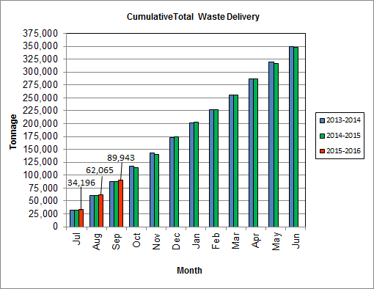

As depicted in Table 3 and Chart 8, for the period ending in September 2015; cumulative total waste delivery was 2.3% more compared to the same period in FY15.

Chart 9: Gross Electrical Generation

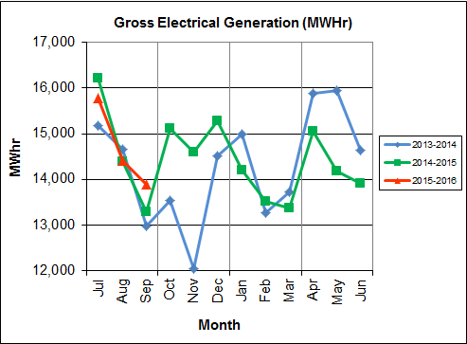

During Q1FY16, the Facility generated 44,083 MWhrs (gross) of electricity compared to Q1FY15 generation of 43,891 MWhrs (gross), a 0.4% increase. The increase in gross electrical generation in Q1FY16 as compared to Q1FY15 is attributable to the increase in steam production, offset by more downtime (75.0 additional hours) experienced by the Turbine Generators. Note that the sharp spikes depicted in Chart Nos. 10 through 14 for the months of May and June 2015 are a result of significant downtime (424.7 hours) experienced by Turbine Generator No. 1 to repair an exciter failure in the generator. A similar spike is depicted in the same charts for November 2013 as a result of Turbine Generator No. 2 experiencing significant downtime (494.8 hours) for a Major Overhaul.

Chart 10: Gross Conversion Rate

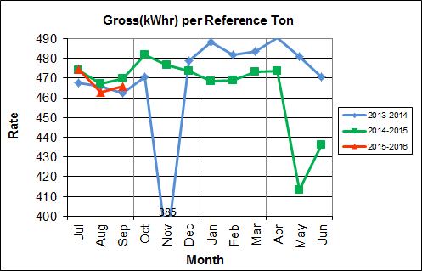

As shown in Chart 10, the average gross electrical generation per reference ton of refuse processed during Q1FY16 was 468 kWhr, which is 0.6% lower than the corresponding quarter in FY15, and is attributable to the downtime experienced by Turbine Generator No. 1. Since this calculated value uses reference or normalized tonnages of waste, it should cancel the effect of MSW heating value (Btu content) variability.

Chart 11: Net Conversion Rate

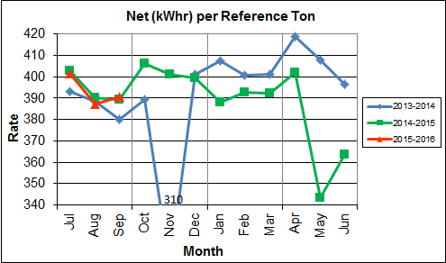

Chart 11 depicts the normalized net power (gross minus in-house usage) generation history. In Q1FY16, the average net electrical generation per reference ton was 393 kWhr, which is 0.3% lower than the corresponding quarter in FY15, and attributable to the downtime experienced by Turbine Generator No. 1 during the quarter.

Chart 12: Net Conversion Rate

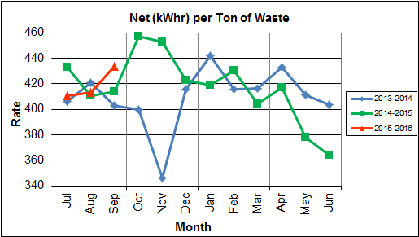

Chart 12 depicts the net power generation per processed ton. The net electrical generation per processed ton in Q1FY16 was 419 kWhr, which is nearly identical (less than 0.1% lower) to the corresponding quarter in FY15.

Chart 13: Gross Turbine Generator Conversion Rate

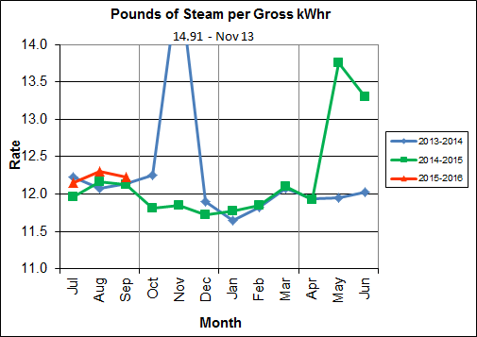

Charts 13 and 14 illustrate the quantities of steam required to generate one kWhr of electricity, gross and net respectively. This measure is a turbine generator performance indicator, where lower steam rates indicate superior performance. For simplification, this calculated rate is based on the average for the two turbine generators. In Q1FY16 the average lbs of steam consumed per gross kWhr generated was 12.2, which is higher (1.3%) than the corresponding quarter Q1FY15, and indicative of poorer performance as a result of more downtime experienced by the turbine generators during the quarter. Another contributing factor to the decline in this metric is Turbine Generator No. 2 continues to operate with its Stage 9 blades removed from the rotor. CAAI reported that during the Turbine Generator No. 2 overhaul in November 2013, some cracking was observed on the Stage 9 blades of the rotor, and the blading in that row was removed as a precautionary measure. CAAI originally indicated that a new set of blades would be manufactured and installed during a Turbine Generator No. 2 Outage in 2016, but advised in May 2015, that the implementation of the replacement blades installation would be delayed. The average lbs of steam consumed per net kWhr was 14.6, which is higher (1.0%) than the corresponding quarter in FY15. The average steam temperature during the quarter was 678.1° F, which is 0.9% lower than the average steam temperature of the corresponding quarter last year and 21.9° F lower than design temperature of 700o F.

Chart 14: Net Turbine Generator Conversion Rate

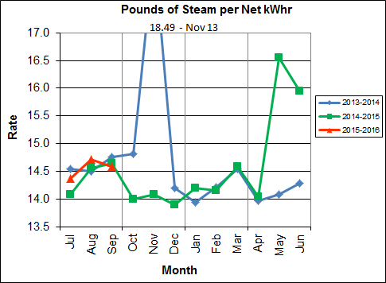

## Utility and Reagent Consumptions

Table 4: Facility Utility and Reagent Consumptions

|  |  |  |  |  |  |  |  |
| --- | --- | --- | --- | --- | --- | --- | --- |
| **Utility** | **Units** | **Q1FY16 Total** | **Q1FY15**  **Total** | **Q1FY16”Per Processed Ton” Consumption** | **Q1FY15”Per Processed Ton” Consumption** | **FY16**  **YTD Total** | **FY15**  **Total** |
| **Purchased Power** | MWhr | 5,477 | 5,549 | 0.06 | 0.06 | 5,477 | 22,001 |
| **Fuel Oil** | Gal. | 10,510 | 7,660 | 0.12 | 0.09 | 10,510 | 35,920 |
| **Boiler Make-up** | Gal. | 2,066,000 | 2,459,000 | 23.33 | 28.05 | 2,066,000 | 8,501,000 |
| **Cooling Tower Make-up** | Gal. | 42,240,267 | 40,727,344 | 476.90 | 464.61 | 42,240,267 | 143,594,395 |
| **Pebble Lime** | Lbs. | 1,334,000 | 1,182,000 | 15.06 | 13.48 | 1,334,000 | 5,254,000 |
| **Ammonia** | Lbs. | 166,000 | 172,000 | 1.87 | 1.96 | 166,000 | 632,000 |
| **Carbon** | Lbs. | 102,000 | 104,000 | 1.15 | 1.19 | 102,000 | 408,000 |
| **Dolomitic Lime** | Lbs. | 248,000 | 264,000 | 2.80 | 3.01 | 248,000 | 984,000 |

Fuel oil usage during the quarter represents approximately 0.18% of the total heat input to the boilers, which compares favorably with industry averages, and slightly lower than the percentage of heat input in Q1FY16 which was 0.13%. Fuel oil is used to stabilize combustion of wet fuel, as well as during start-up and shut-down of the boilers for maintenance. Boiler makeup water usage during the quarter represents 3.2% of steam flow, and is acceptable. Pebble lime usage, at 1,334,000 lbs. is higher (12.9%) than the corresponding quarter last year, and the quarterly consumption rate of 15.1 lbs/ton is less than historical levels (16-18 lbs/ton).

In comparing Q1FY16 to Q1FY15 on a per processed ton consumption basis:

* the purchased power consumption rate was 2.3% lower
* the total fuel oil consumption rate was 35.8% higher
* the boiler make-up water consumption rate was 16.9% lower
* the cooling tower make-up water consumption rate was 2.7% higher
* the total pebble lime consumption rate was 11.7% higher
* the ammonia consumption rate was 4.5% lower
* the carbon consumption rate was 2.9% lower
* the total dolomitic lime consumption rate was 7.0% lower

CAAI reports that the significant increase in fuel oil consumption during the quarter is attributable to usage to stabilize combustion of wet fuel, as a lot of rain was experienced during the quarter.

## Safety & Environmental Training

The Facility had no recordable accidents during the quarter and has operated 1,777 days without an OSHA recordable incident through the end of September 2015. During the quarter, Safety and Environmental training was conducted with themes as follows:

**July 2015**

* Safety:
  + Heat Stress
  + Personal Protective Equipment
  + Tipping Floor Safety
* Environmental:
  + Environmental Impacts
  + Environmental Permits
  + Vector Control

**August 2015**

* Safety:
  + Behavior Based Safety
  + Accident Prevention
  + Housekeeping & Ergonomics
  + CPR/AED and First Aid Training
* Environmental:
  + Receiving & Screening Incoming Waste Deliveries

**September 2015**

* Safety:
  + Control of Hazardous Energy
  + Lock-out-Tag-out (LOTO)
  + Electrical Safety
  + Field Remote Lock Boxes
* Environmental:
  + Unauthorized Waste
  + Startup/Shutdown/Malfunction
  + Annual Emergency Communications (ECOM) Review

# Facility Maintenance

Throughout the quarter, significant routine and preventative maintenance was performed. HDR considers that the Facility is implementing an effective maintenance regimen, and is performing routine and preventative maintenance, along with selected equipment replacements in a timely manner. CAAI monthly maintenance reports provide a detailed account of maintenance performed.

Beginning July 29, Boiler No. 1 experienced 23.9 hours of downtime for scheduled cleaning. Beginning September 19, Boiler No. 1 experienced 100.0 hours of downtime for scheduled maintenance. Some significant maintenance activities that occurred during the outage were:

* Change-out of north side water wall drains and two (2) gate valves
* Change-out of south side water wall drain line upper gate valve
* Replacement of the Boiler High Drum Safety Valve
* Replacement of the Carbon Feeder
* Replacement of two (2) driving beam guide rollers and one (1) support roller on the stoker
* Installation of a new access door to the atomizer lube oil cooler sump
* Balance of No. 1 Induced Draft Fan
* Replacement of G9B No. 4 and G9B No. 10 soot blower elements
* Installation of 22 tube shields in the superheater section
* Replacement of the Opacity Monitor

In addition to the scheduled maintenance activities conducted on Boiler No. 1, CAAI reports that 943 preventative maintenance actions were completed during the quarter. Note that maintenance is scheduled for the remaining two (2) boilers next quarter (Q2FY16) with the following dates:

* Boiler No. 2: October 10, 2015 – October 15, 2015
* Boiler No. 3: November 7, 2015 – November 12, 2015

A list of significant maintenance activities conducted during the outages for Boiler Nos. 2 and 3 will be included in the next Quarterly Report.

## Availability

Facility availabilities for Q1FY16 are shown in Table 5. According to CAAI reports, the average unit availabilities for Boiler Nos. 1, 2, and 3 for Q1FY16 were 94.1%, 97.9%, and 98.5%, respectively. The three-boiler average availability during the quarter was 96.8%, which is good.

During Q1FY16, the average availability for Turbine Generator Nos. 1 and 2 was 99.0%, and 99.1%. The two-turbine generator average availability during the quarter was 99.0%, which is good.

Table 5: Quarterly Facility Unit Availabilities

|  |  |
| --- | --- |
| **Availability** | **Q1FY16 Average** |
| Boiler No. 1 | 94.1% |
| Boiler No. 2 | 97.9% |
| Boiler No. 3 | 98.5% |
| ***Avg.*** | ***96.8%*** |
| Turbine No. 1 | 99.0% |
| Turbine No. 2 | 99.1% |
| ***Avg.*** | ***99.0%*** |

## Downtime Summary

During the quarter, the Facility experienced eight (8) instances of unscheduled downtime for the boilers totaling 98.8 hours, and four (4) instances of unscheduled downtime for the turbine generators totaling 75.0 hours. Beginning July 29, 2015, Boiler No. 1 experienced 35.5 hours of downtime for scheduled maintenance, and again, beginning September 19, 2015 for 100.0 hours. During the quarter, the boilers experienced three (3) instances of standby time totaling 106.8 hours, and Turbine Generator No. 1 experienced one (1) instance of standby time totaling 32.5 hours. Details of downtime events experienced during the quarter are portrayed in Tables 6 and 7:

Table 6: Boiler Downtime – Q1FY16

|  |  |  |  |  |  |  |
| --- | --- | --- | --- | --- | --- | --- |
| **Boiler Number** | **Outage Begin Date** | **Outage End Date** | **Hours Unavailable** | | **Downtime**  **Classification** | **Reason Unavailable** |
| 1 | 7/29/15 | 7/30/15 | 23.9 | | Scheduled | Scheduled Boiler Cleaning |
| 3 | 8/17/15 | 8/18/15 | 45.5 | | Standby | Preventative measure taken to avoid exceeding 350,000 ton rolling 12-month process limit |
| 1 | 8/19/15 | 8/20/15 | 44.0 | | Standby | Preventative measure taken to avoid exceeding 350,000 ton rolling 12-month process limit |
| 1 | 8/28/15 | 8/28/15 | 11.6 | | Unscheduled | Failed Breaker on the Electric Motor Control Center (EMCC) Switchgear |
| 2 | 8/28/15 | 8/28/15 | 14.0 | | Unscheduled | Failed Breaker on the Electric Motor Control Center (EMCC) Switchgear |
| 3 | 8/28/15 | 8/28/15 | 15.0 | | Unscheduled | Failed Breaker on the Electric Motor Control Center (EMCC) Switchgear |
| 3 | 8/29/15 | 8/29/15 | 11.7 | | Unscheduled | Waterwall Failure – External Leak |
| 1 | 9/12/15 | 9/12/15 | 8.8 | | Unscheduled | Malfunction at Van Dorn Substation |
| 2 | 9/12/15 | 9/21/15 | 7.8 | | Unscheduled | Malfunction at Van Dorn Substation |
| 3 | 9/12/15 | 9/21/15 | 5.9 | | Unscheduled | Malfunction at Van Dorn Substation |
| 1 | 9/19/15 | 9/23/15 | 100.0 | | Scheduled | Fall 2015 Scheduled Boiler Outage |
| 1 | 9/24/15 | 9/25/15 | 17.3 | | Standby | Preventative measure taken to avoid exceeding 350,000 ton rolling 12-month process limit |
| 2 | 9/30/15 | 9/30/15 | 24.0 | | Unscheduled | Waterwall Failure – Unprotected Area |
| **Total Unscheduled Downtime** | | | | **98.0 Hours** | | |
| **Total Scheduled Downtime** | | | | **123.9 Hours** | | |
| **Total Standby Downtime** | | | | **106.8 Hours** | | |
| **Total Downtime** | | | | **329.5 Hours** | | |

Table 7: Turbine Generator Downtime – Q1FY16

|  |  |  |  |  |  |  |
| --- | --- | --- | --- | --- | --- | --- |
| **Turbine Generator Number** | **Outage Begin Date** | **Outage End Date** | **Hours Unavailable** | | **Downtime**  **Classification** | **Reason Unavailable** |
| 1 | 8/17/15 | 8/18/15 | 32.5 | | Standby | Boiler No. 3 in Standby for Process Limitations |
| 1 | 8/28/15 | 8/28/15 | 14.2 | | Unscheduled | Failed Breaker on the Electric Motor Control Center (EMCC) Switchgear |
| 2 | 8/28/15 | 8/28/15 | 10.2 | | Unscheduled | Failed Breaker on the Electric Motor Control Center (EMCC) Switchgear |
| 1 | 9/12/15 | 9/12/15 | 9.0 | | Unscheduled | Malfunction at Van Dorn Substation |
| 2 | 9/12/15 | 9/12/15 | 9.1 | | Unscheduled | Malfunction at Van Dorn Substation |
| **Total Unscheduled Downtime** | | | | **42.5 Hours** | | |
| **Total Scheduled Downtime** | | | | **0.0 Hours** | | |
| **Total Standby Downtime** | | | | **32.5 Hours** | | |
| **Total Downtime** | | | | **75.0 Hours** | | |

## Facility Housekeeping

CAAI is performing Facility housekeeping and maintaining plant cleanliness in accordance with acceptable industry practices. A site inspection was conducted in August 2015. At the time of the inspection, new deficiencies were recorded and prior deficiencies were given a status update. Photos of interest from the inspection are depicted in Appendix B. The Facility housekeeping ratings from the August 2015 inspection are presented in Table 8.

Table 8: Facility Housekeeping Ratings – August 2015

| **Facility Area** | **Acceptable** | **Needs Improvement** | **Unacceptable** |
| --- | --- | --- | --- |
| **Tipping Floor** |  | √(1) |  |
| **Citizen’s Drop-off Area** |  | √(2) |  |
| **Tipping Floor Truck Exit** | √ |  |  |
| **Front Parking Lot** | √ |  |  |
| **Rear Parking Lot** | √ |  |  |
| **Boiler House Pump Room** | √ |  |  |
| **Lime Slurry Pump Room** | √ |  |  |
| **Switchgear Area** | √ |  |  |
| **Ash Load-out Area** | √ |  |  |
| **Vibrating Conveyor Area** | √ |  |  |
| **Ash Discharger Area** | √ |  |  |
| **Cooling Tower Area** | √ |  |  |
| **Truck Scale Area** | √ |  |  |
| **SDA/FF Conveyor Area** | √ |  |  |
| **SDA Penthouses** | √ |  |  |
| **Lime Preparation Area** | √ |  |  |
| **Boiler Drum Levels** | √ |  |  |
| **Turbine Room** |  | √(3) |  |
| **Electrical Room** | √ |  |  |

**Note (1): Tipping Floor – Needs Improvement**

* Deteriorated Purlin

**Note (2): Citizen’s Drop-off Area – Needs Improvement**

* Damaged Curbing

**Note (3): Turbine Room – Needs Improvement**

* Ceiling panels corroded

# Environmental

The retrofit air pollution control equipment maintained emission concentrations well within the established regulations. Average Continuous Emission Monitoring System (CEMS) data collected for each monthly period during Q1FY16 are summarized in Appendix A. The Facility experienced no environmental exceedances during the quarter.

On August 8, 2014, CAAI sent a letter to the Virginia Department of Environmental Quality (VADEQ) requesting relief from the steam permit limit requirements in the Facility’s Title V and PSD permits. These requested changes relate to the permit values established for the calculated steam-to-waste ratio, which has resulted in a reduction of MSW throughput. In recent discussions, CAAI indicated that it is re-evaluating options to the proposed permit changes, and will provide further updates on this issue.

## Nitrogen Oxide Emissions

During Q1FY16, the monthly emission concentrations of nitrogen oxides (NOx) averaged 165.0 ppmdv, 161.3 ppmdv and 160.7 ppmdv for Boiler Nos. 1, 2, and 3, respectively. CAAI continues to operate the units at the lower (160 ppmdv) set-points, except immediately following a scheduled outage and associated boiler cleaning.

## Sulfur Dioxide Emissions

During Q1FY16 the monthly emission concentration of stack sulfur dioxide (SO2) averaged 0.7 ppmdv, 0.7 ppmdv, and 0.7 ppmdv for Boiler Nos. 1, 2, and 3, respectively. All of these stack SO2 concentrations are significantly below the 40 CFR Subpart Cb requirement of 29 ppmdv @ 7% O2.

## Carbon Monoxide Emissions

During Q1FY16, the average CO emission concentrations on Boiler Nos. 1, 2, and 3 were 31.0 ppmdv, 31.0 ppmdv, and 28.0 ppmdv, respectively, and all are well within permit limits (100 ppmdv, hourly average).

## Opacity

During Q1FY16, the average opacity for Boiler Nos. 1, 2, and 3 was 0.1%, 0.1%, and 0.0% respectively. All of these averages are significantly below the 10% (6-minute) average permit limit.

## Daily Emissions Data

Appendix A, Tables 9, 10, and 11 tabulate the monthly average, maximum, and minimum emissions data for each unit during Q1FY16. Excursions, if any, would appear in bold print. It should be noted that these tabulations of monthly averages, reported here for informational purposes, are based on tabulations of daily averages. These averages do not correlate with official reports to the regulatory agencies because of differences in averaging times and other technical differences required by agency report formats.

## Ash System Compliance

The dolomitic lime feed rate is adjusted periodically in order to maintain a desired ash pH level in the range of 8.0 to 11.0. Since initial startup, the feed rate has varied from between 1 to 9 lbs per ton. Ash Toxicity (TCLP) tests were not performed during Q1FY16.

In addition to semi-annual TCLP testing, CAAI also samples ash monthly in-house, and documents pH readings to adjust dolomitic lime feed rate. The results for the ash pH tests are found below in Chart 15 where each quarter is represented by the average of the respective monthly readings. During Q1FY16, the average ash pH for in-house tests was 10.8, which is approaching the high end of the desired pH range.

Chart 15: Quarterly Ash Test Results

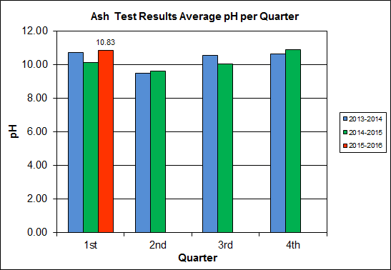

APPENDIX A  
FACILITY CEMS DATA

Table 9: Unit #1 Monthly Summary for Reportable Emissions Data

|  |  |  |  |  |  |  |  |  |  |  |
| --- | --- | --- | --- | --- | --- | --- | --- | --- | --- | --- |
| **Group#-Channel#** | | **G8-C35** | **G8-C28** | **G8-C8** | **G8-C4** | **G8-C12** | **G8-C34** | **G8-C37** | **G8-C40** | **G8-C39** |
| **Long Descrip.** | | **U-1 Steam** | **U-1 Econ** | **U-1 Stack** | **U-1 Stack** | **U-1 Stack** | **U-1 Opaci** | **U-1 FF In** | **U-1 Carbo** | **U-1 Lime** |
| **Short Descrip.** | | **SteamFl** | **SO2ec** | **SO2sc** | **COsc** | **NOxsc** | **Opacity** | **FF InTemp** | **CarbInj** | **LimeFlow** |
| **Units** | | **K#/Hr** | **ppmc** | **ppm** | **ppmc** | **ppmc** | **%** | **deg F** | **#/hr** | **gpm** |
| **Range** | | **0-100** | **0-2000** | **0-500** | **0-4000** | **0-1000** | **0-100** | **100-500** | **0-50** | **0-20** |
| Jul-15 | AVG | 84.7 | 33.0 | 0.0 | 36.0 | 161.0 | 0.0 | 299.0 | 16.6 | 3.1 |
| Max | 89.4 | 83.0 | 1.0 | 49.0 | 186.0 | 0.2 | 300.0 | 18.8 | 3.3 |
| Min | 75.1 | 18.0 | 0.0 | 16.0 | 158.0 | 0.0 | 299.0 | 16.2 | 2.8 |
| Aug-15 | AVG | 83.8 | 54.0 | 1.0 | 28.0 | 169.0 | 0.1 | 300.0 | 16.2 | 3.1 |
| Max | 89.1 | 86.0 | 7.0 | 36.0 | 188.0 | 0.4 | 302.0 | 16.9 | 2.5 |
| Min | 79.8 | 27.0 | 0.0 | 23.0 | 159.0 | 0.0 | 299.0 | 16.0 | 2.8 |
| Sep-15 | AVG | 84.4 | 45.0 | 1.0 | 29.0 | 165.0 | 0.3 | 300.0 | 17.1 | 3.0 |
| Max | 88.8 | 79.0 | 4.0 | 44.0 | 185.0 | 1.1 | 301.0 | 24.8 | 3.5 |
| Min | 76.9 | 27.0 | 0.0 | 16.0 | 155.0 | 0.0 | 300.0 | 16.0 | 2.8 |
| **Quarter Average** | | 84.3 | 44.0 | 0.7 | 31.0 | 165.0 | 0.1 | 299.7 | 16.6 | 3.1 |
| **Quarter Max Value** | | 89.4 | 86.0 | 7.0 | 49.0 | 188.0 | 1.1 | 302.0 | 24.8 | 3.5 |
| **Quarter Min Value** | | 75.1 | 18.0 | 0.0 | 16.0 | 155.0 | 0.0 | 299.0 | 16.0 | 2.8 |
| **Limits:** | | 98 | NA | 29 | 100 | 205 | 10 | 333 | 16(a) |  |

(a) Carbon flow limit is a minimum value

* Note: The data reported herein represent 24 hour average data for all parameters. Emissions excursions that are measured on shorter time intervals (i.e., 4-hour block averages for CO) do not correlate with the 24 hour average data reported above.

Table 10: Unit #2 Monthly Summary for Reportable Emissions Data

|  |  |  |  |  |  |  |  |  |  |  |
| --- | --- | --- | --- | --- | --- | --- | --- | --- | --- | --- |
| **Group#-Channel#** | | **G8-C35** | **G8-C28** | **G8-C8** | **G8-C4** | **G8-C12** | **G8-C34** | **G8-C37** | **G8-C40** | **G8-C39** |
| **Long Descrip.** | | **U-2 Steam** | **U-2 Econ** | **U-2 Stack** | **U-2 Stack** | **U-2 Stack** | **U-2 Opaci** | **U-2 FF In** | **U-2 Carbo** | **U-2 Lime** |
| **Short Descrip.** | | **SteamFl** | **SO2ec** | **SO2sc** | **COsc** | **NOxsc** | **Opacity** | **FF InTemp** | **CarbInj** | **LimeFlow** |
| **Units** | | **K#/Hr** | **ppmc** | **ppm** | **ppmc** | **ppmc** | **%** | **deg F** | **#/hr** | **gpm** |
| **Range** | | **0-100** | **0-2000** | **0-500** | **0-4000** | **0-1000** | **0-100** | **100-500** | **0-50** | **0-20** |
| Jul-15 | AVG | 89.7 | 34.0 | 0.0 | 34.0 | 160.0 | 0.1 | 301.0 | 16.2 | 2.9 |
| Max | 92.8 | 55.0 | 2.0 | 45.0 | 162.0 | 0.2 | 303.0 | 17.3 | 3.3 |
| Min | 85.9 | 18.0 | 0.0 | 24.0 | 157.0 | 0.0 | 301.0 | 16.1 | 2.3 |
| Aug-15 | AVG | 87.3 | 46.0 | 1.0 | 29.0 | 166.0 | 0.1 | 301.0 | 16.1 | 2.9 |
| Max | 91.9 | 94.0 | 3.0 | 39.0 | 181.0 | 1.5 | 302.0 | 16.1 | 3.2 |
| Min | 81.7 | 21.0 | 0.0 | 18.0 | 156.0 | 0.0 | 300.0 | 16.1 | 2.7 |
| Sep-15 | AVG | 87.0 | 53.0 | 1.0 | 30.0 | 158.0 | 0.1 | 302.0 | 16.6 | 3.0 |
| Max | 91.0 | 73.0 | 3.0 | 38.0 | 161.0 | 0.9 | 302.0 | 19.4 | 3.3 |
| Min | 75.5 | 34.0 | 0.0 | 20.0 | 152.0 | 0.0 | 301.0 | 16.1 | 2.7 |
| **Quarter Average** | | 88.0 | 44.3 | 0.7 | 31.0 | 161.3 | 0.1 | 301.3 | 16.3 | 2.9 |
| **Quarter Max Value** | | 92.8 | 94.0 | 3.0 | 45.0 | 181.0 | 1.5 | 303.0 | 19.4 | 3.3 |
| **Quarter Min Value** | | 75.5 | 18.0 | 0.0 | 18.0 | 152.0 | 0.0 | 300.0 | 16.1 | 2.3 |
| **Limits:** | | 96 | NA | 29 | 100 | 205 | 10 | 330 | 16(a) |  |

(a) Carbon flow limit is a minimum value

* Note: The data reported herein represent 24 hour average data for all parameters. Emissions excursions that are measured on shorter time intervals (i.e., 4-hour block averages for CO) do not correlate with the 24 hour average data reported above.

Table 11: Unit #3 Monthly Summary for Reportable Emissions Data

|  |  |  |  |  |  |  |  |  |  |  |
| --- | --- | --- | --- | --- | --- | --- | --- | --- | --- | --- |
| **Group#-Channel#** | | **G8-C35** | **G8-C28** | **G8-C8** | **G8-C4** | **G8-C12** | **G8-C34** | **G8-C37** | **G8-C40** | **G8-C39** |
| **Long Descrip.** | | **U-3 Steam** | **U-3 Econ** | **U-3 Stack** | **U-3 Stack** | **U-3 Stack** | **U-3 Opaci** | **U-3 FF In** | **U-3 Carbo** | **U-3 Lime** |
| **Short Descrip.** | | **SteamFl** | **SO2ec** | **SO2sc** | **COsc** | **NOxsc** | **Opacity** | **FF InTemp** | **CarbInj** | **LimeFlow** |
| **Units** | | **K#/Hr** | **ppmc** | **ppm** | **ppmc** | **ppmc** | **%** | **deg F** | **#/hr** | **gpm** |
| **Range** | | **0-100** | **0-2000** | **0-500** | **0-4000** | **0-1000** | **0-100** | **100-500** | **0-50** | **0-20** |
| Jul-15 | AVG | 87.4 | 56.0 | 1.0 | 29.0 | 161.0 | 0.0 | 300.0 | 16.4 | 3.3 |
| Max | 91.6 | 87.0 | 3.0 | 39.0 | 178.0 | 0.0 | 303.0 | 18.3 | 3.6 |
| Min | 82.7 | 37.0 | 0.0 | 21.0 | 157.0 | 0.0 | 298.0 | 16.1 | 3.0 |
| Aug-15 | AVG | 84.4 | 45.0 | 1.0 | 27.0 | 162.0 | 0.0 | 302.0 | 16.6 | 3.2 |
| Max | 89.9 | 63.0 | 5.0 | 44.0 | 182.0 | 0.3 | 306.0 | 20.1 | 3.5 |
| Min | 76.1 | 28.0 | 0.0 | 17.0 | 157.0 | 0.0 | 280.0 | 16.2 | 3.0 |
| Sep-15 | AVG | 86.5 | 40.0 | 0.0 | 28.0 | 159.0 | 0.0 | 305.0 | 16.4 | 3.0 |
| Max | 90.7 | 51.0 | 2.0 | 43.0 | 161.0 | 0.2 | 306.0 | 16.8 | 3.5 |
| Min | 77.3 | 26.0 | 0.0 | 17.0 | 153.0 | 0.0 | 302.0 | 16.2 | 2.8 |
| **Quarter Average** | | 86.1 | 47.0 | 0.7 | 28.0 | 160.7 | 0.0 | 302.3 | 16.5 | 3.2 |
| **Quarter Max Value** | | 91.6 | 87.0 | 5.0 | 44.0 | 182.0 | 0.3 | 306.0 | 20.1 | 3.6 |
| **Quarter Min Value** | | 76.1 | 26.0 | 0.0 | 17.0 | 153.0 | 0.0 | 280.0 | 16.1 | 2.8 |
| **Limits:** | | 98 | NA | 29 | 100 | 205 | 10 | 327 | 16(a) |  |

(a) Carbon flow limit is a minimum value

* Note: The data reported herein represent 24 hour average data for all parameters. Emissions excursions that are measured on shorter time intervals (i.e., 4-hour block averages for CO) do not correlate with the 24 hour average data reported above.

APPENDIX B  
SITE PHOTOS – AUGUST 2015

|  |  |
| --- | --- |
| C:\Users\kperrin\Desktop\August 2015\P1010655.JPG  Figure 1: Emergency light fixture, east side of Tipping Floor, not functioning in test mode – New Deficiency | C:\Users\kperrin\Desktop\August 2015\P1010660.JPG  Figure 2: Pot hole, southwest corner of Ash Trailer Canopy – New Deficiency |
| C:\Users\kperrin\Desktop\August 2015\P1010608.JPG  Figure 3: Firing Aisle – From south end looking north – No issues observed | C:\Users\kperrin\Desktop\August 2015\P1010609.JPG  Figure 4: Turbine Generators – No issues observed |
| C:\Users\kperrin\Desktop\August 2015\P1010611.JPG  Figure 5: Repaired charging floor parapet wall – deficiency closed | C:\Users\kperrin\Desktop\August 2015\P1010612.JPG  Figure 6: Refuse Pit – From north end looking south |
| C:\Users\kperrin\Desktop\August 2015\P1010613.JPG  Figure 7: SDA Penthouse – No issues observed (typical of all 3) | C:\Users\kperrin\Desktop\August 2015\P1010615.JPG  Figure 8: Cooling Tower Deck/Ash Trailer Canopy – Photo from SDA Penthouse |
| C:\Users\kperrin\Desktop\August 2015\P1010617.JPG  Figure 9: Boiler Steam Drum – General Observation | C:\Users\kperrin\Desktop\August 2015\P1010619.JPG  Figure 10: Supplemental Waste Elevator at south end of Charging Floor |
| C:\Users\kperrin\Desktop\August 2015\P1010620.JPG  Figure 11: Deaerator No. 1 Vessel – General Observation | **C:\Users\kperrin\Desktop\August 2015\P1010623.JPG**  Figure 12: Ash Trailer Canopy from Cooling Tower Deck – No issues observed |
| C:\Users\kperrin\Desktop\August 2015\P1010661.JPG  Figure 13: Main Condenser No. 2 – No issues observed | C:\Users\kperrin\Desktop\August 2015\P1010626.JPG  Figure 14: Metal Recovery Enclosure – General Observation |
| C:\Users\kperrin\Desktop\August 2015\P1010665.JPG  Figure 15: Ferrous Recovery Magnet | C:\Users\kperrin\Desktop\August 2015\P1010635.JPG  Figure 16: Economizers and SDAs – Photo from Cooling Tower Deck |
| C:\Users\kperrin\Desktop\August 2015\P1010631.JPG  Figure 17: Ammonia Storage Tank – General Observation | C:\Users\kperrin\Desktop\August 2015\P1010632.JPG  Figure 18: Facility Parking and Scales on north side of Facility – Photo looking east from Cooling Tower Deck |
| C:\Users\kperrin\Desktop\August 2015\P1010649.JPG  Figure 19: General Facility Photo from Van Dorn | C:\Users\kperrin\Desktop\August 2015\P1010667.JPG  Figure 20: Steam Coil Air Heater – No issues observed |
| C:\Users\kperrin\Desktop\August 2015\P1010657.JPG  Figure 21: Tipping Floor Operations – No issues observed – Warning signs on all columns | C:\Users\kperrin\Desktop\August 2015\P1010658.JPG  Figure 22: Dominion Virginia Switchyard at Tipping Floor Entrance Road |
| C:\Users\kperrin\Desktop\August 2015\P1010662.JPG  Figure 23: Facility Battery Room – No Issues observed | C:\Users\kperrin\Desktop\August 2015\P1010664.JPG  Figure 24: Main Vibrating Ash Pan – No issues observed |